Chapter 13, Problem 30.

(a) Find the input impedance of the circuit in Fig. 13.98 using the concept of reflected impedance.

(b) Obtain the input impedance by replacing the linear transformer by its T equivalent.

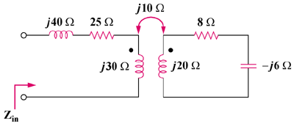

Figure 13.98
For Prob. 13.30.

